

**An Interactive Preschool Adventure!**

**_________________________________________________**

**9321 N. Armenia Ave. Tampa FL 33612** [**earlyscholarsacademy@gmail.com**](mailto:earlyscholarsacademy@gmail.com) **(813) 245 0056**

**APPLICATION FOR ADMISSION**

**Note:** All children applying to Early Scholars must be potty trained by the time of enrollment.

Check (🗹) boxes that apply.

**Student Information**

Student’s Name: _________________________________________________________________________________

*Last First Middle Nickname*

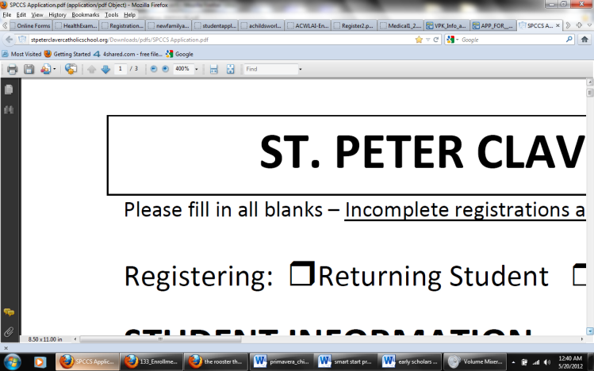 Male Female Date of Birth **MM- DD- YYYY**  Present Age: **Years / Months**

Home Address: ________________________________________________________________________________

*Street City State Zip Code*

Home Phone #: (____)_________________ Social Security Number (Optional)_____-_______-_______

Proposed Entrance Date: ___________ Class Applying to:__________ Place of Birth:_________________________

U.S Citizen? Yes No

Race/Ethnic Group: ___ American Indian/ Native Alaskan ___ Asian

___ African-American/Black ___ Hispanic/Latino

___ Native Hawaiian/ Pacific Islander ___ Multi-Racial

___ White/Caucasian ___ Other

Former Schools (if applicable): __________________________________Class: ________________

Family Contact E-mail Address: ______________________________

To whom should additional documents and reports be sent?____________________________________

Language(s) spoken in the home: __________________________________________________________

Religion (optional):________________________________

Medical alert information (Allergies, Medical and/or Challenging conditions, additional info):

__________________________________________________________________________________

Usually take a nap?Yes **____** No **___**

|  |  |
| --- | --- |
| **Days per week (*select one*)** | 5 days (M-F) 3 Days (M, W, F) |
| **Hours**  ***(select one)*** | Full Time (8:00 am-6:00 pm) Part Time (8:00 am- 11:30) |

If enrolling in EC-4 (4 years old ***on or before*** September 1st, 2019)…..

|  |  |
| --- | --- |
| **VPK Academic**  **Year**  **(August–April)** | Morning Session Only Full Day  (8:00 am – 11:30 am) VPK Funded (11:30 am -6:00 pm)  VPK + WrapAround |

After- School Hours requested? Yes No

**Family Information** Check (🗹) boxes that apply.

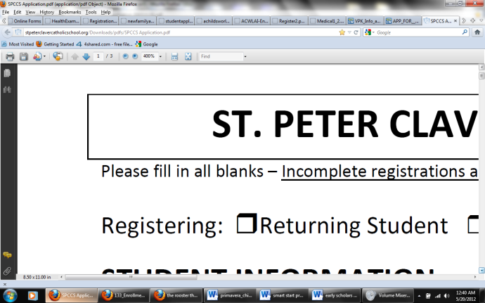Parents are: Single Married Separated Divorced

 Mother Remarried Father Remarried Father Deceased Mother Deceased

*Student’s Legal Guardian: Both Parents Mother Father Other: ___________________________

***\*NOTE: IF SINGLE, DIVORCED, OR SEPARATED, COURT CUSTODIAL DOCUMENTS MUST BE SUBMITTED AT TIME OF REGISTRATION.***

Student lives with: Father Mother Stepfather Stepmother Other: ___________________

*Check all that apply* *Please Specify*

Who is financially responsible for the applicant?______________________________________________

Is the student adopted? Yes No

Name of Applicant’s Sibling(s)/ Age(s):

_______________________ Age: _______ Sex:____ _______________________ Age: _______ Sex:_____

_______________________ Age: _______ Sex:____ _______________________ Age: _______ Sex:_____

**Parent/Guardian Information**

**Father/ Guardian’s Full Name**: (Mr./ Dr.)_____________________________________________________________

*First Middle Last*

Home Address: __________________________________________________________________________________

*(if different from student’s) Street City State Zip Code*

Home Phone: (____) _________________ Cell Phone: (____) _________________ E-Mail: ____________________

*(if different from student’s)*

Employer: _____________________________________ Position: _______________________________________

Business Address: ________________________________________________________________________________

*Street City State Zip Code*

Work Phone: (____) _________________

**Mother/ Guardian’s Full Name**: (Mrs./Ms.)____________________________________________________________

*First Middle Last*

Home Address: __________________________________________________________________________________

*(if different from student’s) Street City State Zip Code*

Home Phone: (____) _________________ Cell Phone: (____) ______________ E-Mail: _____________________

*(if different from student’s)*

Employer: _____________________________________ Position: _______________________________________

Business Address: ________________________________________________________________________________

*Street City State Zip Code*

Work Phone: (____) _________________

**Step-Parent/ Guardian’s Full Name**: (Mr./Dr./Mrs./Ms.)_________________________________________________

*First Middle Last*

Home Address: __________________________________________________________________________________

*(if different from student’s) Street City State Zip Code*

Home Phone: (____) _________________ Cell Phone: (____)______________ E-Mail: ______________________

*(if different from student’s)*

Employer: _____________________________________ Position: _______________________________________

Business Address: ________________________________________________________________________________

*Street City State Zip Code*

Work Phone: (____) _________________

**Grandparents Information**

**Paternal Grandparents Maternal Grandparents**

_____________________________________ _____________________________________

*Name Name*

_____________________________________ _____________________________________

*Home Address*  *Home Address*

_____________________________________ _____________________________________

*City State Zip Code*  *City State Zip Code*

_____________________________________ _____________________________________

*Current/Past Profession Current/Past Profession*

***Signature***

I certify that all the above information is true and correct to the best of my knowledge.

Parent/ Guardian Signature: ______________________________­­______ Date:________________

Parent/ Guardian Signature: ______________________________­­______ Date:________________